

FFFor Action: Assistant Director Integrated Care, Head of Pharmacy and Medicines Management, HSC Board & BSO  Heads of Pharmacy and Medicines Management of HSC Trusts  Regulation Quality Improvement Authority |  | From: Chief Pharmaceutical Officer  Dr Mark Timoney  Castle Buildings  Upper Newtownards Road  Belfast BT4 3SQ  Telephone: 028 90 523219  Facsimile: 028 90 522335  E-Mail: mark.timoney@health-ni.gov.uk  Our Ref: PHC/4/2018  Date: 22 February 2018

D R U G A L E R T
CLASS 2 MEDICINES RECALL
Action within 48 hours
Pharmacy & Wholesaler Level Recall

Dear Healthcare Professional

Glaxo Wellcome UK Ltd
Seretide Accuhaler 50 microgram/250 microgram/dose inhalation powder, pre-dispensed |  |  | PL 10949/0315
(Salmeterol/Fluticasone Propionate)
Lot Number | Expiry Date | Pack Size |  | First Distributed
5K8W | 04-2019 | 1 x 60 doses |  | 29-Aug-2017

Brief description of the problem

Glaxo Wellcome UK Limited is recalling the above Lot of Seretide Accuhaler 50/250mcg because a manufacturing issue with this Lot has been identified which has resulted in a small number of units not delivering the full number of doses.

Please note, this is not a patient level recall.

Advice for healthcare professionals

Please take the following actions:
- Quarantine any remaining stock of this Lot and return to the original supplier for credit.
- The location of Lot number and expiry is as shown in the images below.

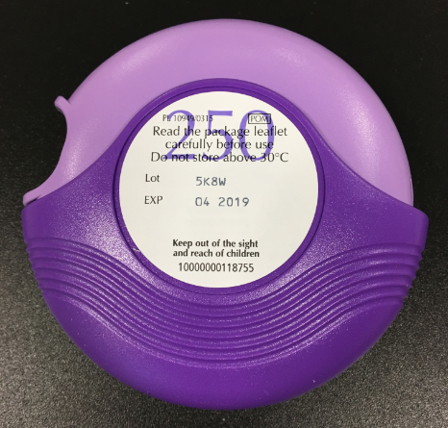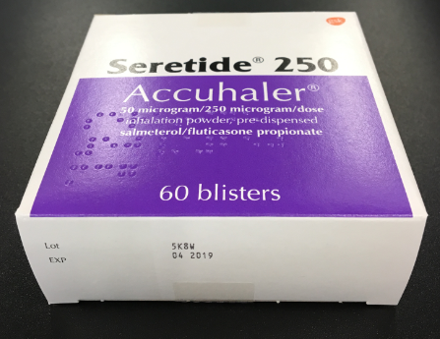

Wholesalers
- Quarantine any remaining stock of this Lot and return to the original supplier for credit

Medical Information enquiries: For medical information enquiries, please contact GSK via customercontactuk@gsk.com, Live Chat facility on https://hcp.gsk.co.uk/contact-us/live-chat.html or by calling 0800 221 441 (option 4).

Stock enquiries: For stock enquiries please refer to www.hcp.gsk.co.uk/supply.html or contact
0800 221 441 (option 1).

RQIA should bring this information to the attention of private hospitals/clinics registered with them and any other relevant care facilities

The Business Services Organisation is asked to bring this information to the attention of Community Pharmacists and General Medical Practitioners directly.

Yours sincerely

Dr Mark Timoney
Chief Pharmaceutical Officer

