

FFFor Action: Assistant Director Integrated Care, Head of Pharmacy and Medicines Management, HSC Board & BSO  Heads of Pharmacy and Medicines Management of HSC Trusts  Regulation Quality Improvement Authority |  | From: Chief Pharmaceutical Officer  Dr Mark Timoney  Castle Buildings  Upper Newtownards Road  Belfast BT4 3SQ  Telephone: 028 90 523219  Facsimile: 028 90 522335  E-Mail: mark.timoney@health-ni.gov.uk  Our Ref: PHC/3/2018  Date: 22 February 2018

D R U G A L E R T
CLASS 2 MEDICINES RECALL
Action within 48 Hours
Patient, Pharmacy and Wholesaler Level Recall

Dear Healthcare Professional

Glaxo Wellcome UK Ltd
Ventolin Accuhaler 200mcg |  |  | PL 10949/0252
(Salbutamol Sulfate)
Lot Number | Expiry Date | Pack Size |  | First Distributed
786G | 05-2019 | 1 x 60 doses |  | 02-Oct-2017
754P | 05-2019 | 1 x 60 doses |  | 31-Aug-2017

Brief description of the problem

Glaxo Wellcome UK Limited is recalling the above Lots of Ventolin Accuhaler 200mcg because a manufacturing issue with these Lots has been identified which has resulted in a small number of units not delivering the full number of doses.

Advice for healthcare professionals

General Practices please take the following actions:
- Identify patients or carers who have received Ventolin Accuhaler since 31 August 2017
- Contact these patients or carers to notify them of this issue and ask them to check whether their Ventolin Accuhalers have Lot numbers 786G or 754P printed on the device and packaging. Refer patient/carer to Community Pharmacy if they have any difficulty carrying this out.
- The location of Lot number and Expiry is as shown in the images below

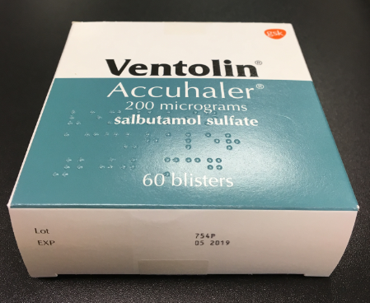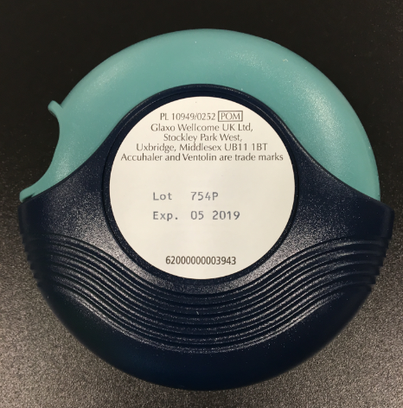

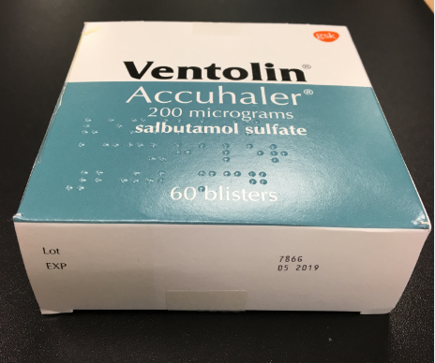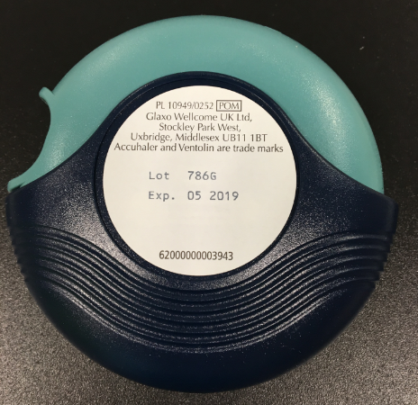

- If the patient or carer has any Ventolin Accuhalers 200mcg from these Lots, they should be asked to return them to their pharmacy or their dispensing practice for replacement with a different Lot number. Please provide replacement packs to patients at point of return, to ensure that affected patients are not left without a supply of their medicine.
- Display the attached poster.

Community Pharmacies please take the following actions:
- Quarantine any remaining stock of these Lots and return to the original supplier for credit.
- Bring this alert to the attention of your patients when issuing prescriptions.
- Display the attached poster.
- Please provide replacement packs to patients at point of return, to ensure that affected patients are not left without a supply of their medicine.

Wholesalers
- Quarantine any remaining stock of these Lots and return to the original supplier for credit.

Patients

- If you have received any Ventolin Accuhalers 200mcg since 31 August 2017, check whether either of the Lot numbers 786G or 754P are printed on the device or any of the packaging.
- The lot number appears on the bottom of the Ventolin Accuhaler cardboard package (four characters after the word ‘Lot) or in the centre of the device (similarly four characters after the word ‘Lot’)
- If you have any Ventolin Accuhalers from these Lots, take them to your pharmacy or your dispensing practice and speak to a pharmacist who will provide a replacement.

Medical Information enquiries:
For medical information enquiries, please contact customercontactuk@gsk.com, via our Live Chat facility on https://hcp.gsk.co.uk/contact-us/live-chat.html or on 0800 221 441 (option 4).

Stock enquiries: For stock enquiries, please refer to www.hcp.gsk.co.uk/supply.html or contact
0800 221441 (option 1).

RQIA should bring this information to the attention of private hospitals/clinics registered with them and any other relevant care facilities

The Business Services Organisation is asked to bring this information to the attention of Community Pharmacists and General Medical Practitioners directly.

Yours sincerely
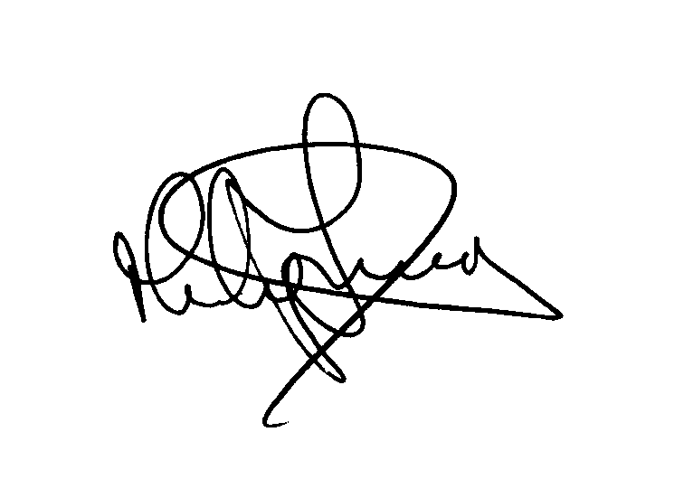
Dr Mark Timoney
Chief Pharmaceutical Officer

DRUG RECALL POSTER

VENTOLIN ACCUHALER 200MCG

PATIENTS

- If you have received any Ventolin Accuhalers 200mcg since 31 August 2017, check whether either of the Lot numbers 786G or 754P are printed on the device or any of the packaging.
- The lot number appears on the bottom of the Ventolin Accuhaler cardboard package (four characters after the word ‘Lot) or in the centre of the device (similarly four characters after the word ‘Lot’)
- If you have any Ventolin Accuhalers from these Lots, take them to your community pharmacy and speak to a pharmacist who will provide a replacement.

