From the Interim Chief Nursing Officer  Linda Kelly  VIA EMAIL:  Amanda Jackson  Assistant Director (Assurance)  Agencies Team  The Regulation and Quality Improvement Authority  Amanda.Jackson@rqia.org.uk  To forward onwards to nursing agencies. | 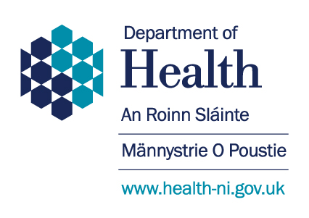  Department of Health  C4.20  Castle Buildings  Stormont Estate  Belfast BT4 3SQ  Tel: 02890523136  Email:  Linda.Kelly@health-ni.gov.uk  Date: 23 December 2021
FAO: Nursing Agencies,
This letter outlines some areas of focus to prepare for the anticipated wave of the Omicron variant of COVID-19 during the coming weeks.
Omicron is currently circulating internationally and is quickly replacing Delta as the dominant strain of COVID-19 across the UK, including Northern Ireland. Whilst the disease severity associated with Omicron is not yet well understood, this variant is spreading very quickly and all precautions must be put in place as soon as possible to protect the most vulnerable. It is important to continue to focus on the important steps to mitigate the spread of the virus:
Infection Prevention Control (IPC): Public health measures to prevent infection will continue to be an essential cornerstone in defence against infection. COVID-19 spreads through the air by droplets and aerosols that are exhaled from the nose and mouth of an infected person. Strict adherence to infection prevention and control requirements, especially hand washing, use of well-fitting face masks and other PPE. All staff should adhere to the Public Health Agency and Trust or recruiting organisational IPC policies/protocols.
Vaccination: Early evidence regarding vaccination suggests that a third booster dose is required to provide effectiveness against symptomatic disease with the Omicron variant i.e. 2 doses which were effective against Delta variant may not be enough to protect against severe illness with Omicron. All staff who have not already done so and who are eligible are encouraged to have a booster of COVID-19 vaccine at any of the walk in clinics or pharmacies or GP surgery.
Testing and exposure: All agency staff should adhere to the public health guidance and trust policy on staff testing. Online requests https://www.gov.uk/order-coronavirus-rapid-lateral-flow-tests; Additional supplies of LFD tests will be available in Trusts or pharmacies. Management of health and social care workers identified as close contacts of confirmed COVID-19 cases, including household and non-household contacts should follow the DOH guidance. https://www.health-ni.gov.uk/sites/default/files/publications/health/doh-hss-md-85-2021f.pdf.
The emerging evidence remains under continuous monitoring and public health and staff guidance may change accordingly. Where agency staff require further advice specific to the organisation where they are working they should contact the recruiting bank office.
May I take this opportunity to thank you and all your staff for your ongoing hard work and support over what has been a challenging 2021, your input has been invaluable. I wish you a happy Christmas and prosperous New Year.
Yours sincerely

Interim Chief Nursing Officer

